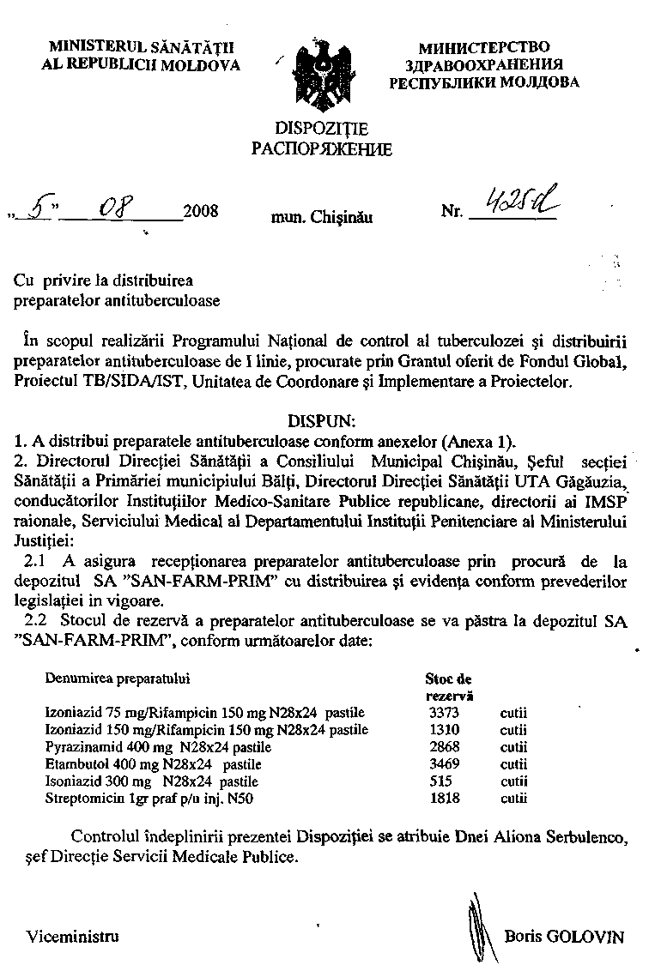

APROB:

Anexa 1 la dispoziţia MS
 | 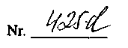din

Viceministru Boris Golovin
 | Distribuţia preparatelor antituberculoase procurate din sursele Fondului Global
 | Teritoriul | N de bolnavi tr.II 2008 | Pirazinamidă 0,4 |  | Etambutol 0,4 |  | Streptomicină 1,0 |  | Izoniazidă 0,15 +Rifampicină 0,15 |  | Izoniazidă 0,075 +Rifampicină 0,15
 | Teritoriul | Nr. De paturi
 | Teritoriul | Nr. De paturi | Stoc | Distrib | Stoc | Distrib | Stoc | Distrib | Stoc | Distrib | Stoc | Distrib
 | Teritoriul | Nr. De paturi | 1 fl./1000 tab | 1 cut / 28x24tab | 1 fl./1000 tab | 1 cut / 28x24tab | 50 fl/ amb | 50 fl/ amb | 1 fl./1000 tab | 1 cut / 28x24tab | 1 fl./1000 tab | 1 cut / 28x24tab
 | IMSP Spitalul Municipal de Ftiziopneumo-logie Chişinău | 244 | 237 | 0 | 231 | 0 | 509 | 300 | 138 | 0 | 266 | 0
 | IMSP Spitalul Municipal de Ftiziopneumo-logie Chişinău | 325
 | SM Bălţi | 88 | 92 | 60 | 97 | 0 | 94 | 0 | 34 | 0 | 126 | 0
 | SM Bălţi | 185
 | SR Anenii-Noi | 30 | 2 | 6 | 0 | 6 | 0 | 20 | 1 | 12 | 4 | 4
 | SR Basarabeasca | 2 | 1 | 1 | 3 | 0 | 5 | 2 | 0 | 3 | 2 | 2
 | SR Briceni | 14 | 0 | 6 | 0 | 5 | 7 | 20 | 0 | 0 | 0 | 6
 | SR Cahul | 33 | 0 | 15 | 4 | 7 | 16 | 20 | 3 | 13 | 3 | 12
 | SR Cantemir | 16 | 2 | 5 | 3 | 2 | 1 | 10 | 2 | 4 | 2 | 5
 | SR Călăraşi | 28 | 3 | 10 | 5 | 11 | 0 | 30 | 2 |  | 5 | 7
 | SR Căuşeni / Căinari | 18 | 5 | 5 | 0 | 7 | 10 | 10 | 0 | 3 | 6 | 2
 | SR Cimişlia | 9 | 3 | 1 | 0 | 4 | 1 | 10 | 2 | 2 | 2 | 2
 | SR Criuleni | 38 | 6 | 10 | 3 | 10 | 1 | 30 | 0 | 1 | 6 | 10
 | SR Donduşeni | 6 | 1 | 2 | 1 | 1 | 1 | 5 | 0 | 3 | 2 | 1
 | SR Drochia | 28 | 3 | 10 | 1 | 9 | 0 | 25 | 1 | 1 | 3 | 10
 | SR Edineţ | 15 | 4 | 2 | 6 | 0 | 12 | 10 | 2 | 3 | 0 | 8
 | SR Făleşti | 20 | 5 | 3 | 13 | 0 | 5 | 20 | 0 | 0 | 6 | 2
 | SR Floreşti | 36 | 10 | 2 | 0 | 14 | 11 | 40 | 1 | 2 | 13 | 2
 | SR Floreşti | 30
 | SR Glodeni | 17 | 4 | 3 | 9 | 0 | 15 | 5 | 0 | 2 | 4 | 3
 | SR Hânceşti | 47 | 41 | 0 | 0 | 20 | 66 | 15 | 0 | 2 | 34 | 0
 | SR Hânceşti | 30
 | SR Ialoveni | 27 | 2 | 11 | 14 | 0 | 9 | 20 | 2 | 2 | 0 | 10
 | SR Leova | 11 | 2 | 2 | 2 | 1 | 3 | 10 | 2 | 0 | 2 | 2
 | SR Nisporeni | 23 | 4 | 6 | 2 | 6 | 3 | 20 | 5 | 0 | 12 | 0
 | SR Ocniţa | 10 | 2 | 2 | 0 | 4 | 27 | 0 | 1 | 0 | 2 | 2
 | SR Orhei | 28 | 4 | 9 | 1 | 9 | 5 | 30 | 11 | 0 | 5 | 7
 | SR Rezina | 13 | 3 | 2 | 0 | 5 | 4 | 12 | 0 | 0 | 3 | 2
 | SR Râşcani | 14 | 14 | 0 | 5 | 0 | 6 | 10 | 0 | 0 | 15 | 0
 | SR Sângerei | 17 | 4 | 3 | 3 | 2 | 0 | 20 | 0 | 1 | 4 | 3
 | SR Soroca | 40 | 30 | 0 | 8 | 20 | 3 | 50 | 11 | 0 | 20 | 15
 | SR Soroca | 30
 | SR Străşeni | 32 | 12 | 2 | 17 | 0 | 0 | 30 | 0 | 0 | 13 | 0
 | SR Şoldăneşti | 13 | 6 | 0 | 0 | 5 | 7 | 10 | 0 | 0 | 2 | 4
 | SR Ştefan - Vodă | 14 | 4 | 2 | 2 | 3 | 26 | 0 | 0 | 1 | 3 | 3
 | SR Taraclia | 9 | 2 | 2 | 1 | 2 | 5 | 5 | 2 | 0 | 5 | 0
 | SR Teleneşti | 19 | 0 | 10 | 0 | 7 | 3 | 20 | 9 | 0 | 3 | 5
 | SR Ungheni | 23 | 10 | 0 | 16 | 0 | 60 | 20 | 3 | 0 | 8 | 1
 | SR Comrat | 16 | 0 | 8 | 2 | 3 | 4 | 5 | 0 | 4 | 2 | 5
 | SR Ciadâr- Lunga | 10 | 2 | 2 | 3 | 0 | 9 | 5 | 6 | 0 | 4 | 0
 | SR Vulcăneşti | 11 | 1 | 4 | 6 | 0 | 9 | 5 | 0 | 0 | 1 | 4
 | Institutul de Ftiziopneumologie "Chiril Draganiuc" | 260 | 98 | 80 | 37 | 150 | 66 | 300 | 0 | 0 | 112 | 100
 | Spitalul Clinic Republican de Psihiatrie „Codru” | 21 | 8 | 8 | 9 | 4 | 9 | 40 | 0 | 0 | 0 | 0
 | Spitalul Clinic de Psihiatrie nr.5 Bălţi | 42 | 17 | 16 | 14 | 12 | 0 | 60 | 1 | 10 | 17 | 16
 | Serviciul Medical al Departamentului Instituţii Penitenciare al Ministerului Justiţiei | 88 | 19 | 29 | 54 | 30 | 180 | 30 | 53 | 10 | 46 | 20
 | Spitalul Republican de Ftiziopneumologie "Vorniceni" | 270 | 164 | 44 | 106 | 60 | 254 | 200 | 0 | 0 | 154 | 60
 | TOTAL |  |  | 383 |  | 419 |  | 1474 |  | 79 |  | 335
 | Stocul de rezervă– S.A „SAN-FARM-PRIM” la 01,07,2008 Preparate procurate de FG |  |  | 3371 |  | 4018 |  | 3442 |  | 1484 |  | 3780
 | Stocul de rezervă– S.A „SAN-FARM-PRIM” Preparate procurate de FG, după distribuţie |  |  | 2988 |  | 3599 |  | 1968 |  | 1405 |  | 3445

